Helical Gears

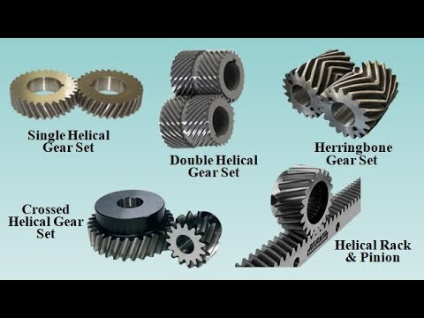

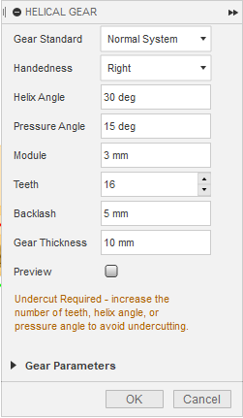

Pressure angle:

Pressure angle is the angle of tooth drive action, or the angle between the line of force between meshing teeth and the tangent to the pitch circle at the point of mesh. Typical pressure angles are 14.5° or 20°.

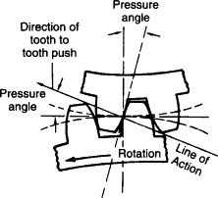

Helix angle:

Helix angle is the angle at which the gear teeth are aligned compared to the axis. test

